**Machine Learning**

**Abstract**

In the modern scientific space, people are going deep into the Artificial Intelligence research. This term means the ability of intelligent machines to perform creative functions that are traditionally considered as the prerogative of human beings. Disputes about the prospects and risks of its wider use are growing but there are no doubts that the Artificial Intelligence (AI) will significantly impact on our world. Machine learning is one of the areas of AI. Its basic principle is that machines receive data and “learn” from it. Unlike programs with manually encoded instructions for performing specific tasks, Machine Learning allows the system to learn how to independently recognize patterns and make predictions. That is what makes Machine Learning one of the most perspective Artificial Intelligence subsections.

**The state of art of ML**

Nowadays, there is a huge number of Machine Learning experiments. The development of this sphere is happening with an incredible speed and people find the use of Machine Learning in different life aspects. These are some examples of the latest researches:

“Aug 16, 2019

Scientists used machine learning to analyze the coevolution of physical traits in butterflies.

A machine learning algorithm revealed that coevolving butterflies “borrow” physical features from each other, such as wing shape and pattern, and use them to generate novel features over time, researchers reported August 14 in Science Advances. The scientists set out to test a model known as Müllerian mimicry, which proposes that species sometimes mimic each other to glean mutual benefits.”

“Machine learning could be the key to reducing the use of animals in experiments.”

“We showed that artificial intelligence (AI) could mine existing data on chemical toxicity and generate new information...The software takes advantage of the power of big data and transfer learning, a machine learning method that applies information from one task or set of items to another.”

There are much more interesting areas where Machine Learning and Artificial Intelligence are used now. We meet some of them in our day to day life. Virtual Personal Assistants, Search Engine Result Refining and even Product Recommendations are useful to many people which sometimes do not know that these applications are of Machine Learning. However, Artificial Intelligence is also in demand in more significant projects. For example, Machine Learning can predict illnesses or population health risk by revealing patterns and markers of high risk. And what is more, one of the primary clinical applications of Machine Learning lies in early-stage drug discovery process as it can process the data that has been collected over many years and sometime decades in very little time. Also, Artificial Intelligence allows government agencies to identify ways of increasing efficiency and save money. All in all, Machine Learning has a huge impact in the modern world. (340)

*The nearest future of Machine Learning*

Machine Learning will have a huge impact on medicine even in a couple years. Numerous researchers are underway on the use of AI to diagnose various diseases, such as cancer. An Artificial Intelligence program called a Neural Network was created this year. It can detect lung cancer with 94 percent accuracy.

“These people have a technology that will improve the precision of screening tremendously,” Otis Brawley, an oncologist and epidemiologist at Johns Hopkins University

At the moment, the program may issue erroneous diagnoses that is why it needs to be improved. However, in the next three years, similar programs will already take effect and diagnose cancer and other diseases in many countries.

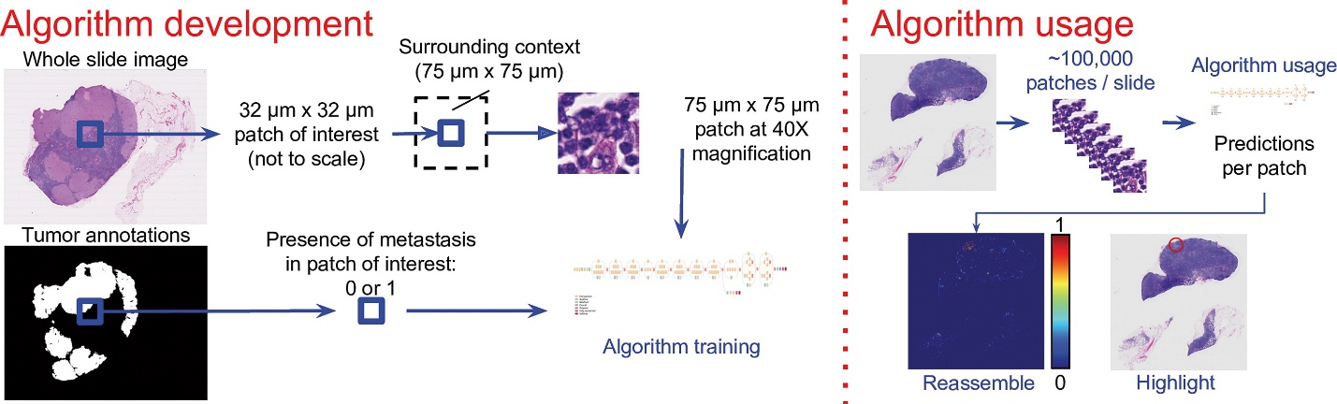

The use of AI and Machine Learning is not just about medicine. They are also able to assist us in developing a healthier relationship to social media.

“Kane’s opinion is that AI can take this same data and provide insightful analyses of what it portends for our overall well-being, mitigating social media’s addictive elements… Kane is therefore suggesting AI could be deployed as a countermeasure. Using its ability to synthesize vast data streams, it could offer a different feedback loop, promising healthier outcomes.”

*Technological development that make it possible:*

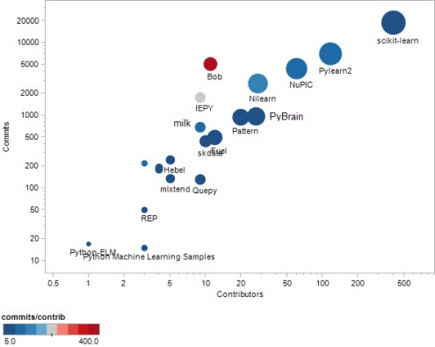

Overall, ML is heading to transform medicine, science, social media and many others aspects of our life.

**The likely impact**

As a result of Machine Learning progress, diagnosis of certain diseases will become automated in many developed countries. Programs which contains a huge amount of information about diseases and their symptoms will be able to determine the diagnosis in the accurate and effective way.

Cancer is among the leading causes of death worldwide. In 2012, there were 14.1 million new cases and 8.2 million cancer-related deaths worldwide. Usually it is due to too late detection of the disease and diagnosis.

Artificial Intelligence programs which can establish an accurate diagnosis in the early stages will completely change this deplorable situation. Mortality from cancer and other diseases will decrease, as it will be revealed when there is still a greater chance of saving a life. This development will have a huge impact on people with cancer and since the number of them is growing every year, creating such programs is very important.

Such technologies will not be able to replace any professions in the next three years, at the same time, they can improve the working process of radiologists. For example, a great low-level Julia deep learning package, to build the models to identify reference cases for physicians.

“While radiologists spend up to 20 minutes searching for information, contextflow using Julia promises to cut down search time to ~2 seconds. Taking into account a global shortage of radiologists, this could be a real solution.”

Another significant ML development of the future is AI assistant in building healthy relationships to social media. Despite the fact that it is not going to fight with global problems, its impact on our day-to-day life will be noticeable.

More than 3 billion people actively use Facebook, Instagram, YouTube and other platforms, leading to an average daily usage of nearly 2.5 hours. These statistics drastically increase when it comes to the younger demographic.

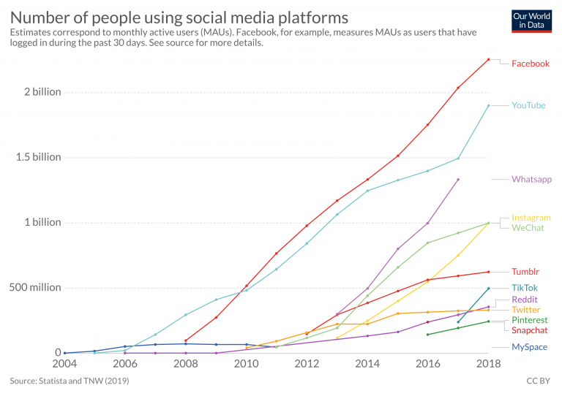

ML can help many people cope with Internet addiction. Not only can the technology provide information on its impact to our overall health, it can also offer suggestions as to how to improve our behavior.

“People sometimes need to be scared into action. We all look at our mobile devices and our computers on a daily basis and see a large number on the screen. But what does that tangibly mean to our overall happiness?” - growth strategist Brendan Kane

As a young person, I spend a lot of time in social media. Therefore, such development can strongly affect me. Sometimes I do not think about how much time I waste on unnecessary things. That is why it is so helpful to remind me about this. Due to ML, it is possible to spend less time on the Internet and this will improve my health and quality of life. Many people, like me, will have more time for self-development and hobbies.

My family and social circle are also full of internet addicts. For example, my younger sister spends more than 9 hours a day on social media. By assessing the big picture, AI assistant can help her more consciously use social media.

In conclusion, having understood the state of Machine Learning and its possible impact on our future, you begin to realize how much of our life it covers.

References

Lanese. (2019) Image of the Day: ButterflyNet [Online] Available at: <https://www.the-scientist.com/image-of-the-day/image-of-the-day--butterflynet-66280>

Hartung. (2019) Opinion: AI Beats Animal Testing at Finding Toxic Chemicals [Online] Available at: <https://www.the-scientist.com/critic-at-large/opinion--ai-beats-animal-testing-at-finding-toxic-chemicals-65795>

Williams. (2019) AI Accurately Detects Lung Cancer in Scans [Online] Available at: <https://www.the-scientist.com/news-opinion/ai-accurately-detects-lung-cancer-in-scans-65914>

[Online] Available at: <https://www.archivesofpathology.org/doi/10.5858/arpa.2018-0147-OA>

Sahota. (2019) A.I. Will Soon Transform Social Media; The Question is How? [Online] Available at: <https://www.forbes.com/sites/cognitiveworld/2019/07/03/a-i-will-soon-transform-social-media-the-question-is-how/#13131a45173a>

Kharkovyna. (2019) Artificial Intelligence & Deep Learning for Medical Diagnosis [Online] Available at: <https://towardsdatascience.com/artificial-intelligence-deep-learning-for-medical-diagnosis-9561f7a4e5f>

Ortiz-Ospina. (2019) The rise of social media [Online] Available at: <https://ourworldindata.org/rise-of-social-media>